Aldehyde Deuteration - Model Search

Table of Contents

Model Search 1

Section Results Summary 1

1st Place 2

2nd Place 9

3rd Place 16

4th Place 23

5th Place 30

6th Place 37

7th Place 44

8th Place 51

9th Place 58

10th Place 65

### Model Search

| formula | McFadden R2 |
| --- | --- |
| class ~ -2-3- + dip_y + Dist(2, 7) + NPA_1 | 0.577 |
| class ~ -2-3- + dip_y + NPA_1 + NPA_3 | 0.577 |
| class ~ dip_y + NPA_3 + diff 1 2 + L | 0.570 |
| class ~ dip_y + Dist(2, 7) + NPA_3 + diff 1 2 | 0.567 |
| class ~ -2-3- + dip_y + NPA_1 + NPA_2 | 0.557 |
| class ~ -2-3- + dip_y + Dist(2, 7) + diff 1 2 | 0.555 |
| class ~ -2-7- + dip_y + NPA_1 + NPA_3 | 0.555 |
| class ~ dip_y + NPA_1 + NPA_3 + diff 2 7 | 0.553 |
| class ~ dip_y + NPA_3 + NPA_7 + diff 1 2 | 0.551 |
| class ~ -2-3- + Total + NPA_1 + NPA_3 | 0.549 |

### Section Results Summary

|  | Training Accuracy | Test Accuracy |
| --- | --- | --- |
| 1. 1st Place | 90.48 | 92.3 |
| 2. 2nd Place | 85.71 | 100.0 |
| 3. 3rd Place | 78.57 | 92.3 |
| 4. 4th Place | 85.71 | 100.0 |
| 5. 5th Place | 80.95 | 92.3 |
| 6. 6th Place | 85.71 | 92.3 |
| 7. 7th Place | 83.33 | 100.0 |
| 8. 8th Place | 83.33 | 100.0 |
| 9. 9th Place | 83.33 | 100.0 |
| 10. 10th Place | 85.71 | 84.6 |

### 1st Place

Table:

Full Model Stats - Overall Accuracy and Pseudo-R2

| Accuracy | McFadden_R2 |
| --- | --- |
| 90.48% | 0.577 |

Model Coefficients

|  | x |
| --- | --- |
| -2-3- | -0.3801322 |
| dip_y | -1.5680528 |
| Dist(2, 7) | 295.8494658 |
| NPA_1 | 47.5647077 |

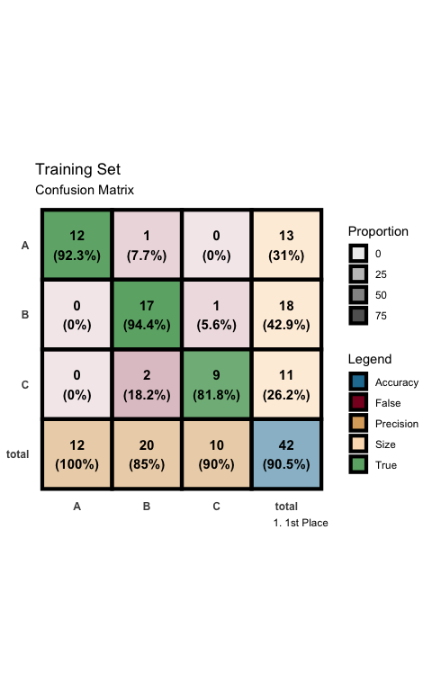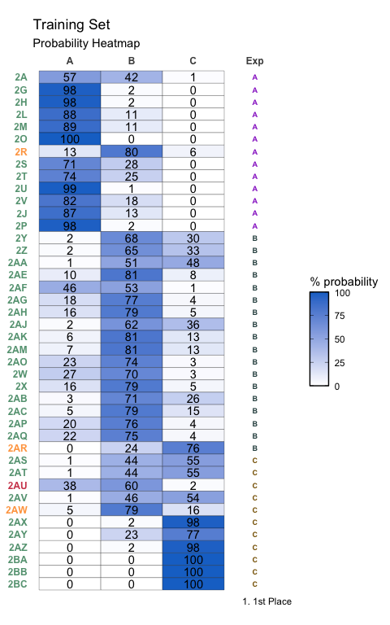

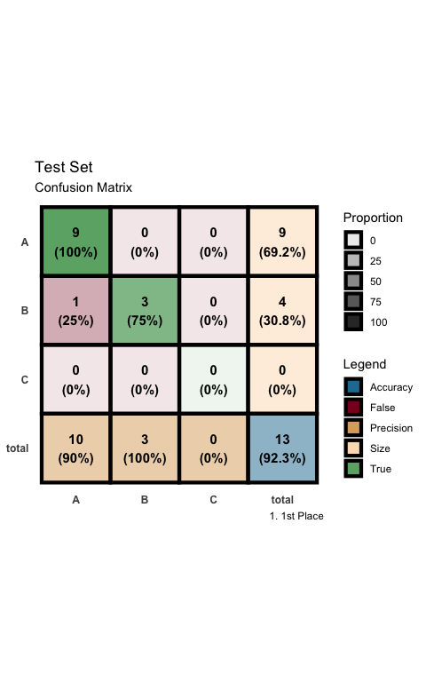

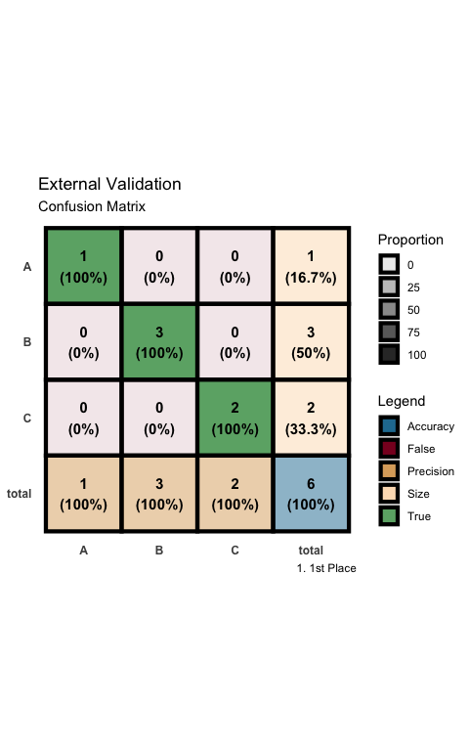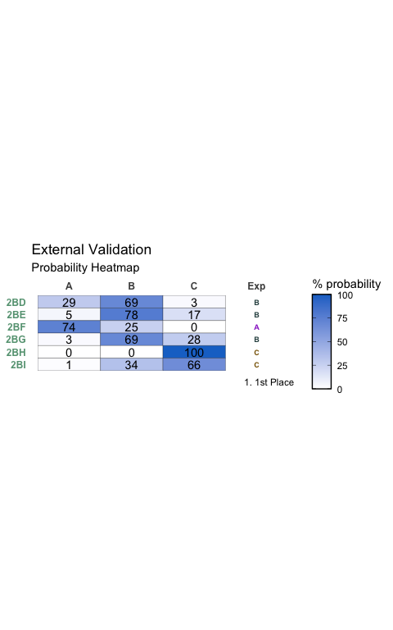

### 2nd Place

Table:

Full Model Stats - Overall Accuracy and Pseudo-R2

| Accuracy | McFadden_R2 |
| --- | --- |
| 85.71% | 0.577 |

Model Coefficients

|  | x |
| --- | --- |
| -2-3- | -0.1316956 |
| dip_y | -1.2386416 |
| NPA_1 | 39.1279581 |
| NPA_3 | -227.3707397 |

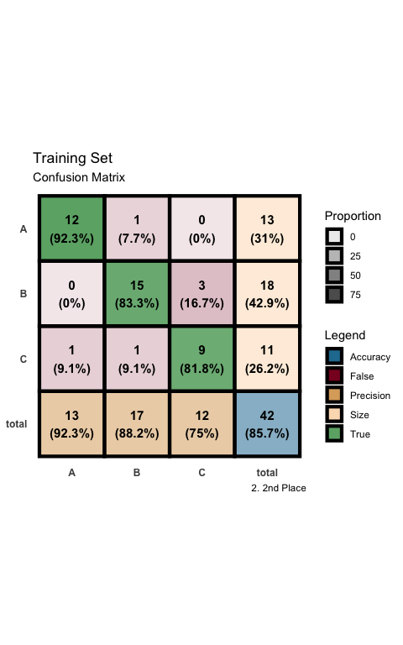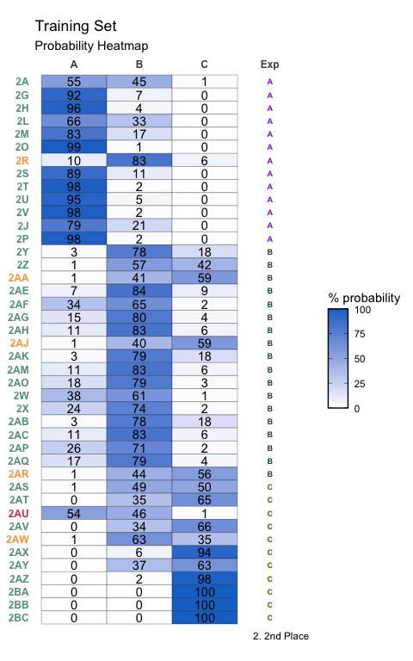

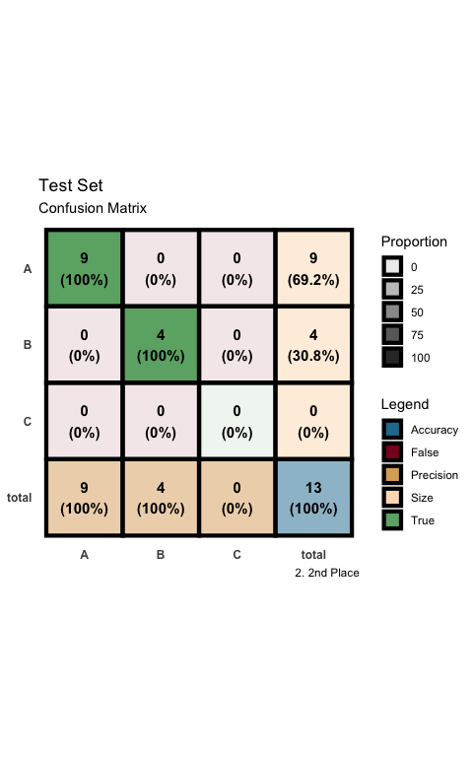

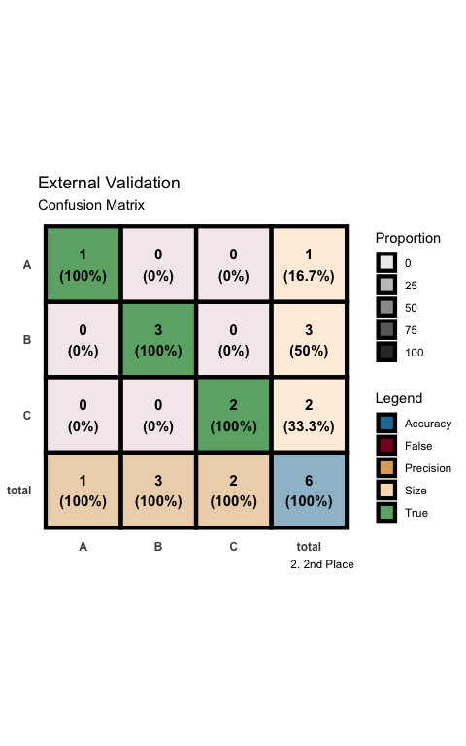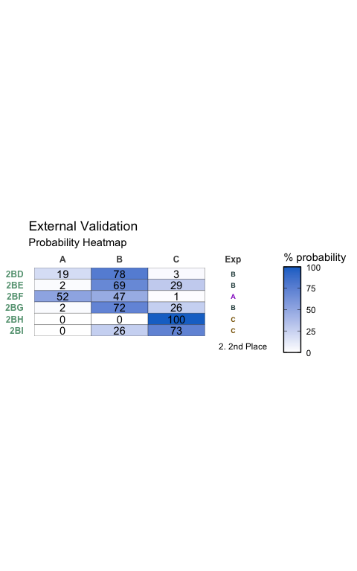

### 3rd Place

Table:

Full Model Stats - Overall Accuracy and Pseudo-R2

| Accuracy | McFadden_R2 |
| --- | --- |
| 78.57% | 0.57 |

Model Coefficients

|  | x |
| --- | --- |
| dip_y | -1.9662387 |
| NPA_3 | -203.6733689 |
| diff 1 2 | -39.1768689 |
| L | -0.4500423 |

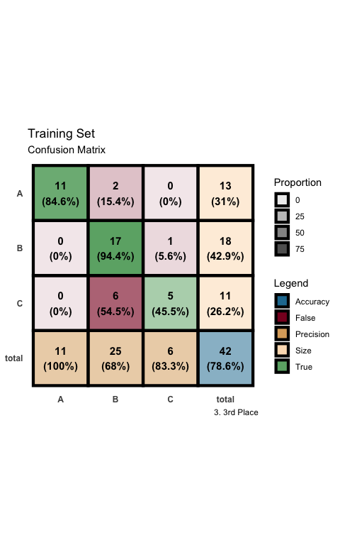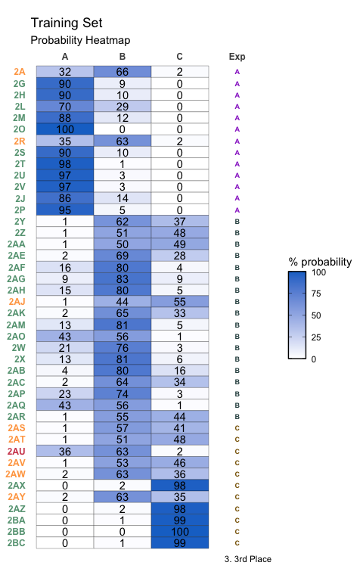

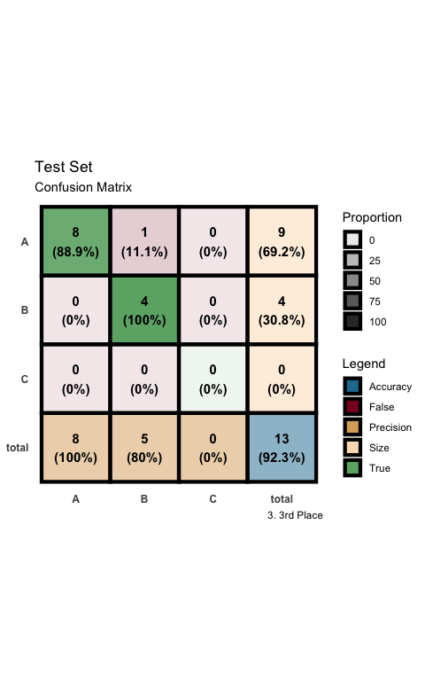

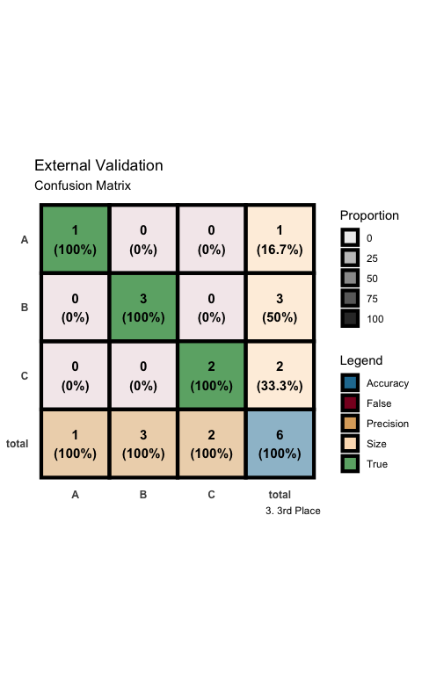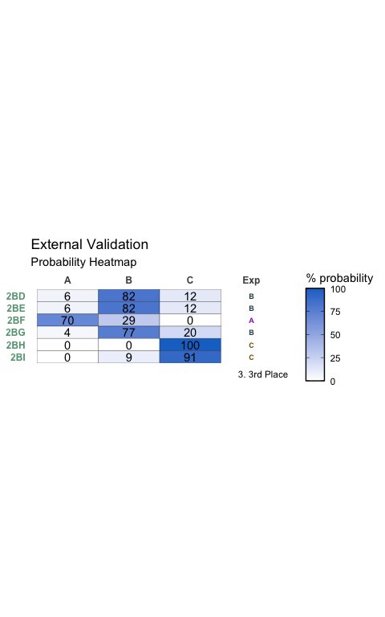

### 4th Place

Table:

Full Model Stats - Overall Accuracy and Pseudo-R2

| Accuracy | McFadden_R2 |
| --- | --- |
| 85.71% | 0.567 |

Model Coefficients

|  | x |
| --- | --- |
| dip_y | -1.212812 |
| Dist(2, 7) | -205.902948 |
| NPA_3 | -298.027882 |
| diff 1 2 | -37.601198 |

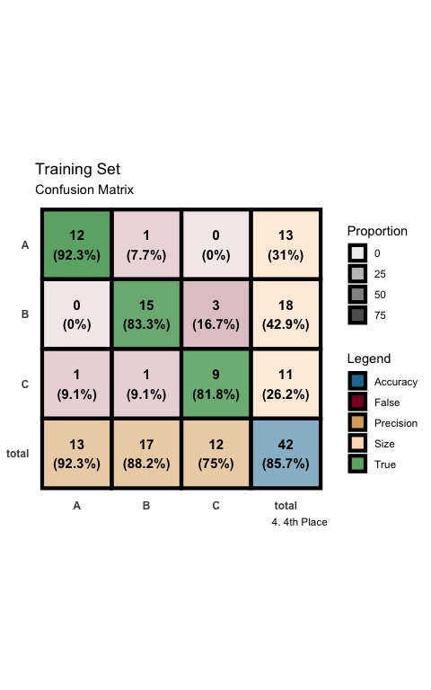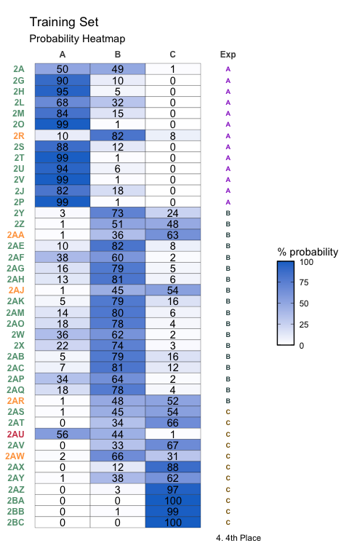

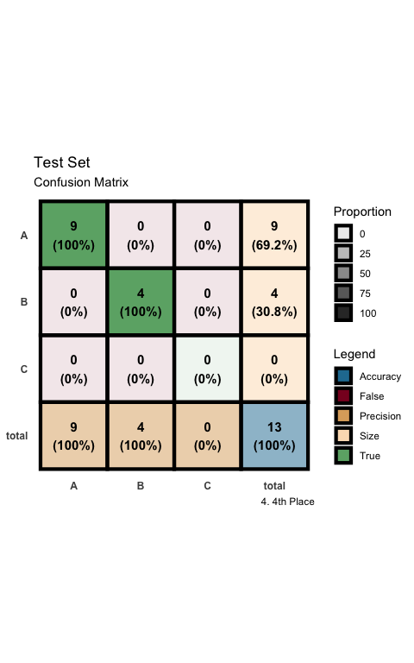

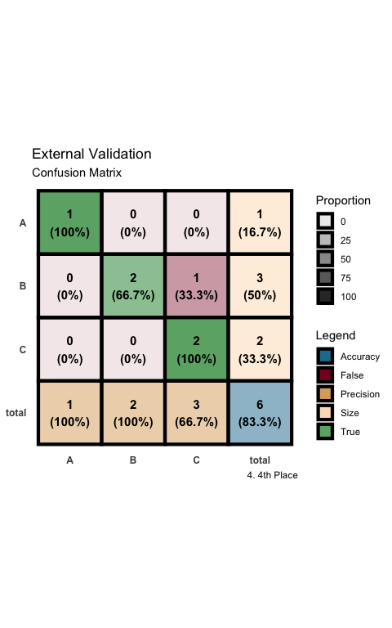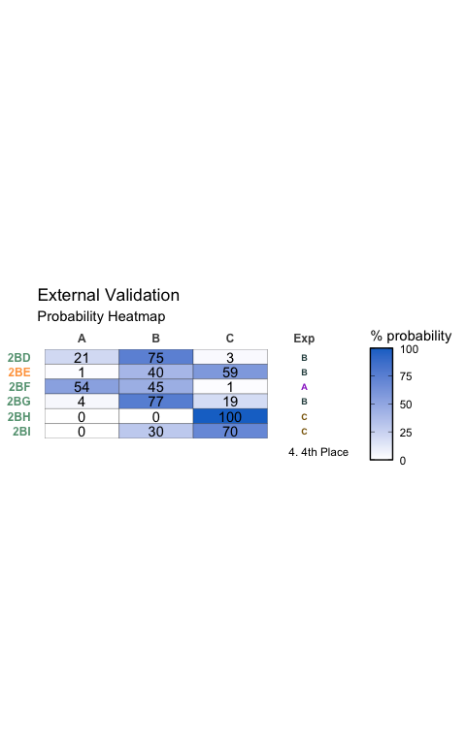

### 5th Place

Table:

Full Model Stats - Overall Accuracy and Pseudo-R2

| Accuracy | McFadden_R2 |
| --- | --- |
| 80.95% | 0.557 |

Model Coefficients

|  | x |
| --- | --- |
| -2-3- | -0.2656046 |
| dip_y | -1.5218006 |
| NPA_1 | 37.0038197 |
| NPA_2 | 58.0760567 |

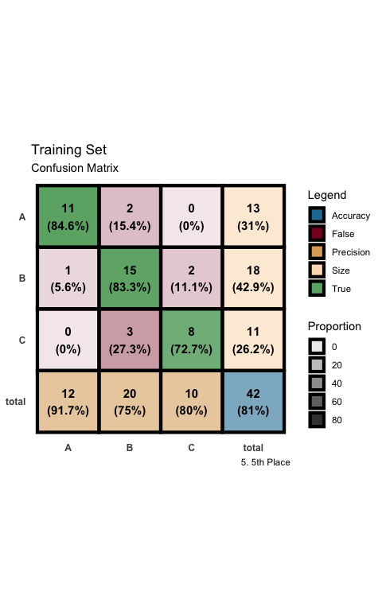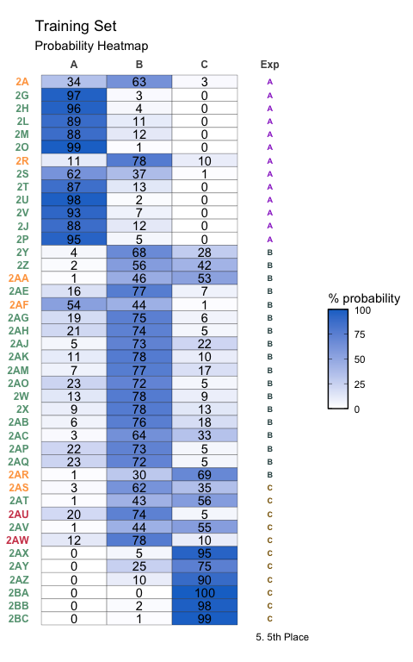

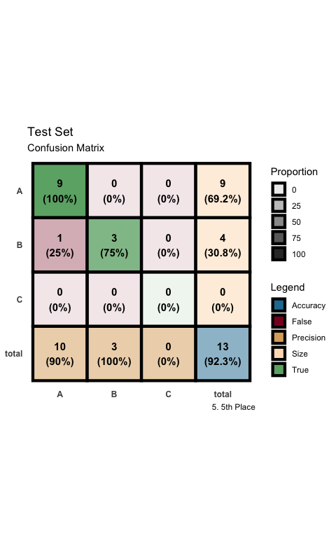

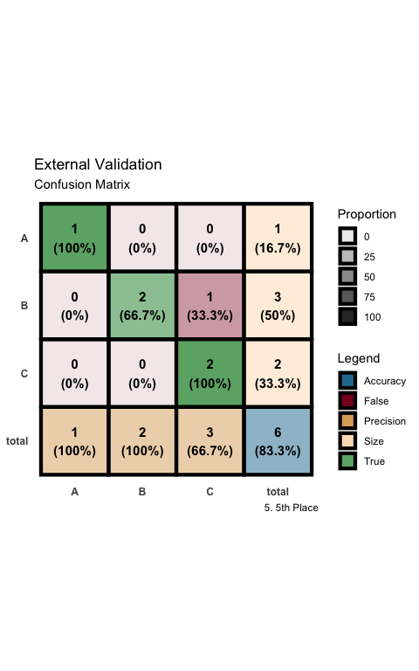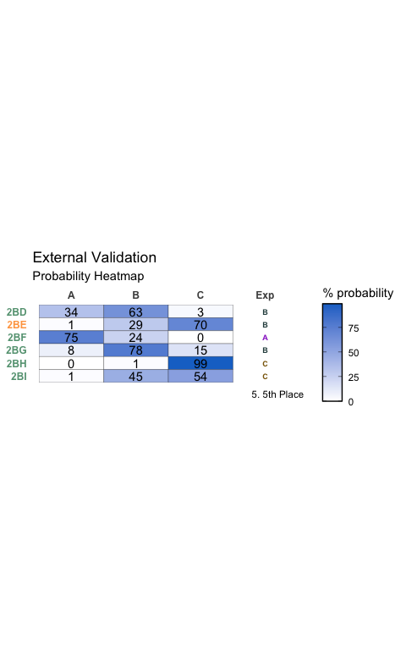

### 6th Place

Table:

Full Model Stats - Overall Accuracy and Pseudo-R2

| Accuracy | McFadden_R2 |
| --- | --- |
| 85.71% | 0.555 |

Model Coefficients

|  | x |
| --- | --- |
| -2-3- | -0.298887 |
| dip_y | -1.568930 |
| Dist(2, 7) | 243.537174 |
| diff 1 2 | -42.690753 |

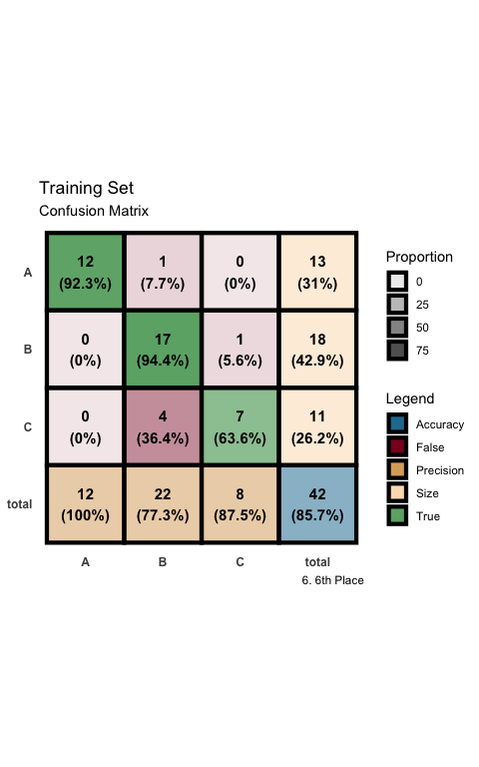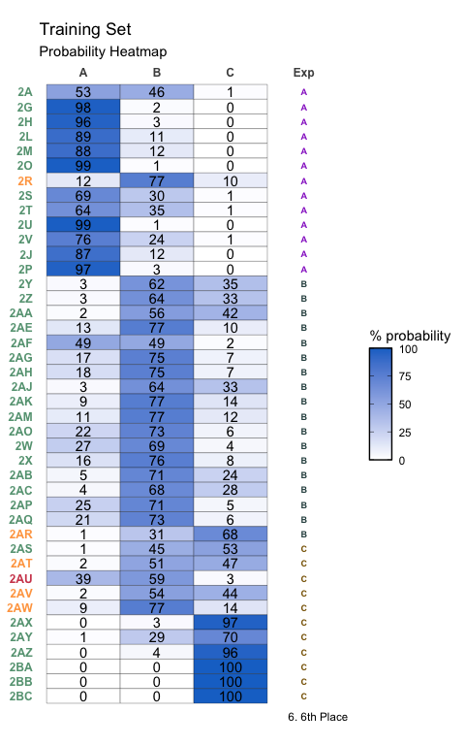

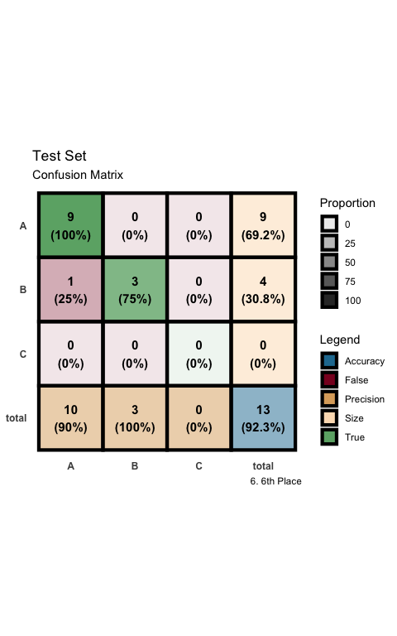

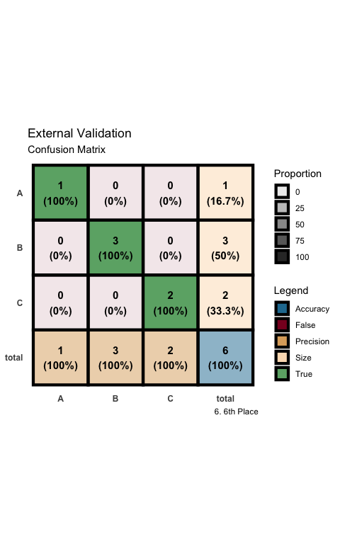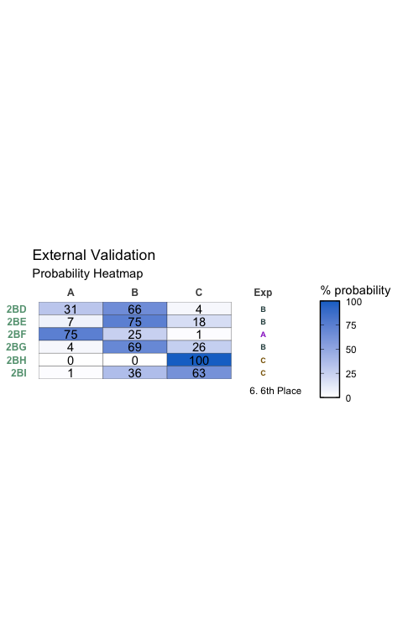

### 7th Place

Table:

Full Model Stats - Overall Accuracy and Pseudo-R2

| Accuracy | McFadden_R2 |
| --- | --- |
| 83.33% | 0.555 |

Model Coefficients

|  | x |
| --- | --- |
| -2-7- | 0.0196432 |
| dip_y | -1.2374931 |
| NPA_1 | 34.2137827 |
| NPA_3 | -247.0244428 |

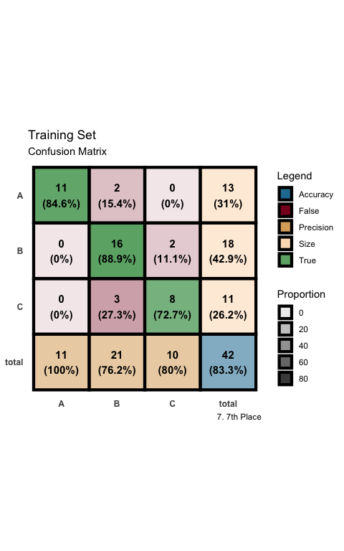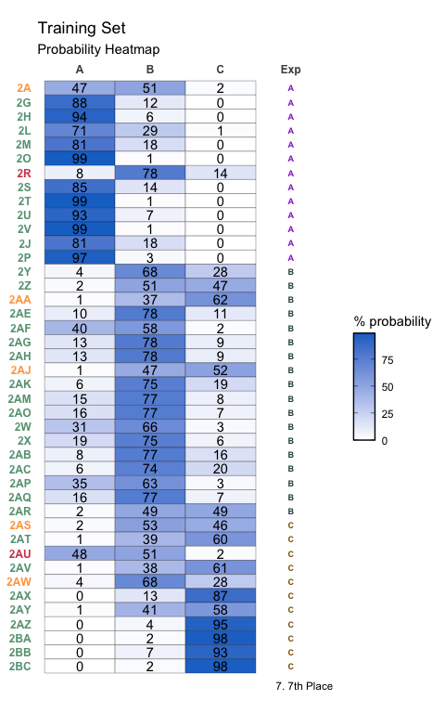

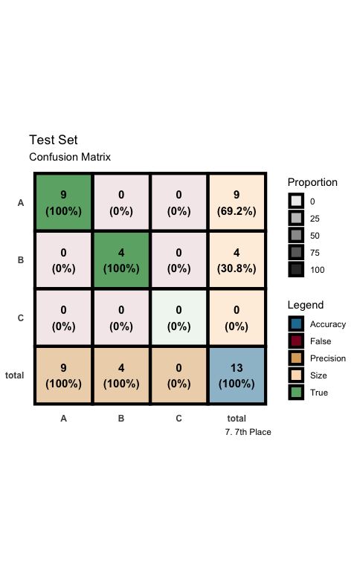

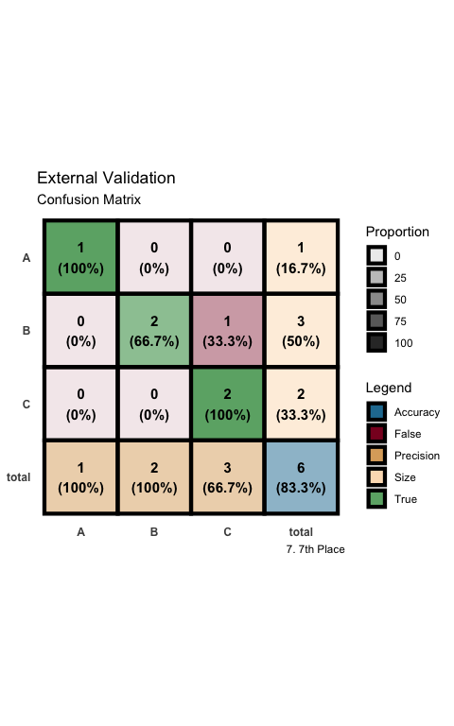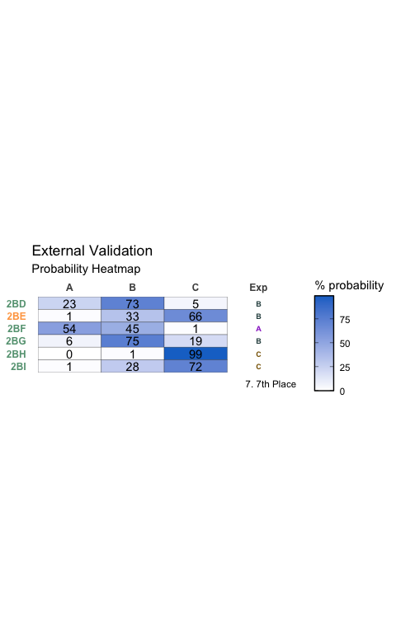

### 8th Place

Table:

Full Model Stats - Overall Accuracy and Pseudo-R2

| Accuracy | McFadden_R2 |
| --- | --- |
| 83.33% | 0.553 |

Model Coefficients

|  | x |
| --- | --- |
| dip_y | -1.267705 |
| NPA_1 | 37.769555 |
| NPA_3 | -256.395854 |
| diff 2 7 | -60.498122 |

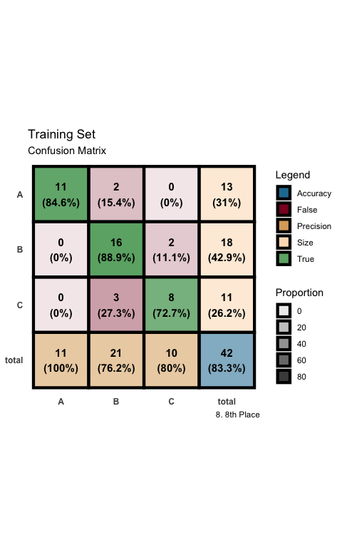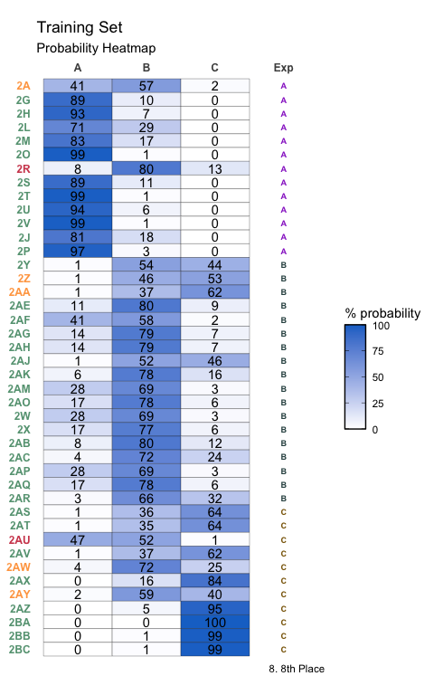

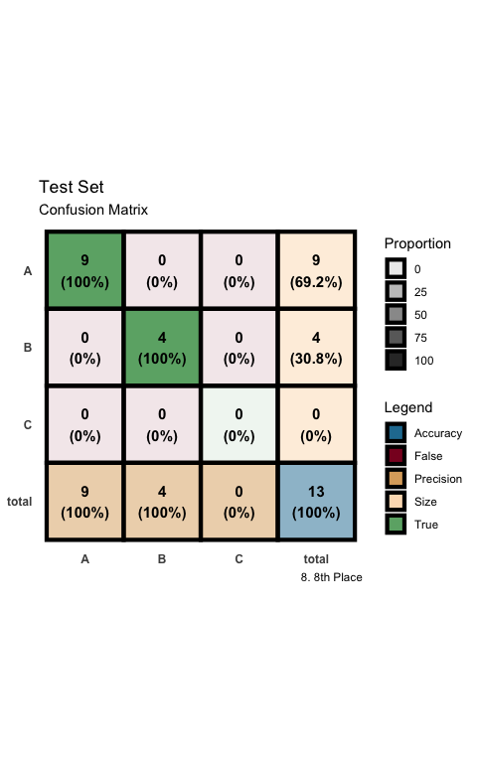

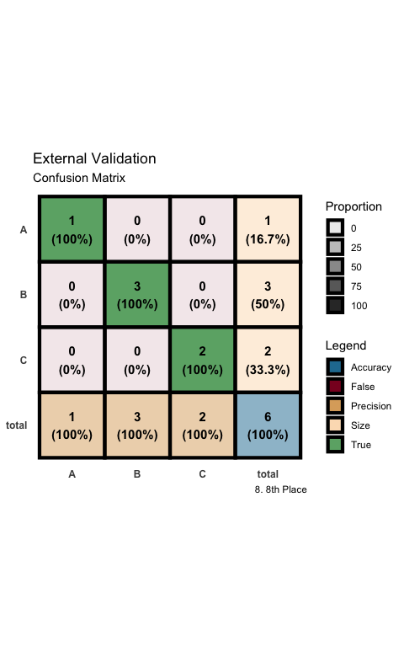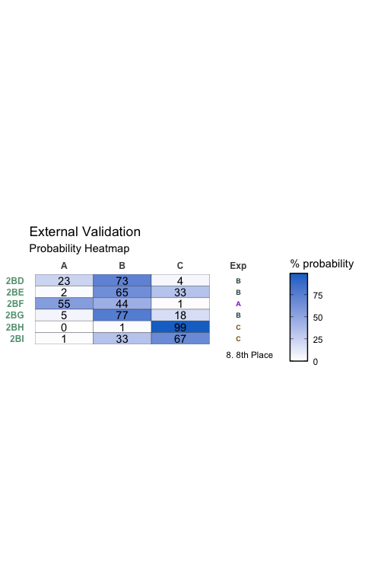

### 9th Place

Table:

Full Model Stats - Overall Accuracy and Pseudo-R2

| Accuracy | McFadden_R2 |
| --- | --- |
| 83.33% | 0.551 |

Model Coefficients

|  | x |
| --- | --- |
| dip_y | -1.311817 |
| NPA_3 | -250.122843 |
| NPA_7 | 57.898207 |
| diff 1 2 | -37.003103 |

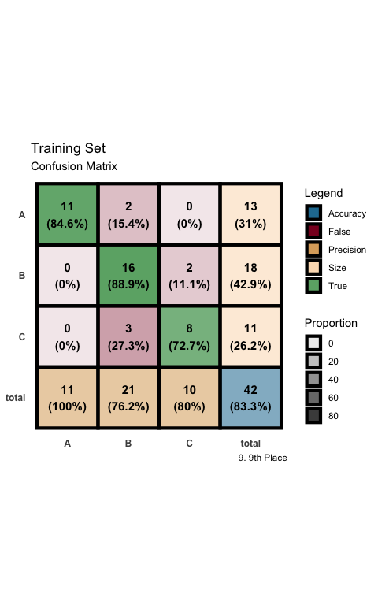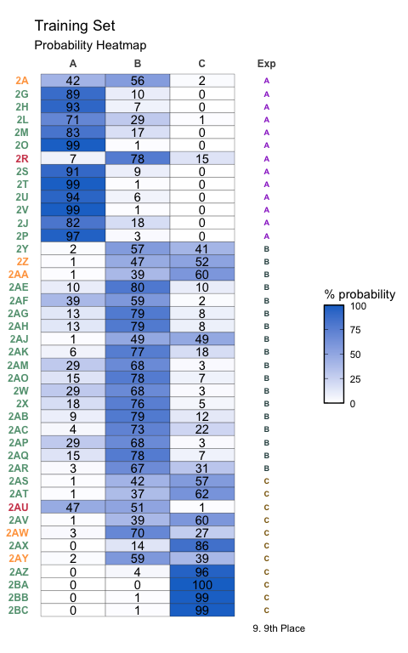

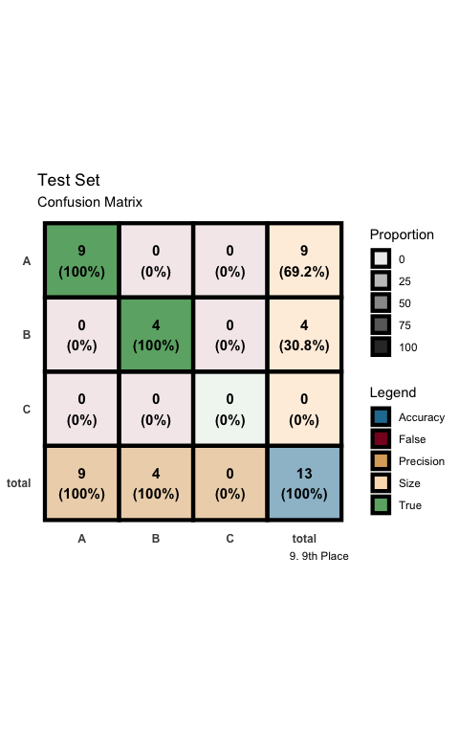

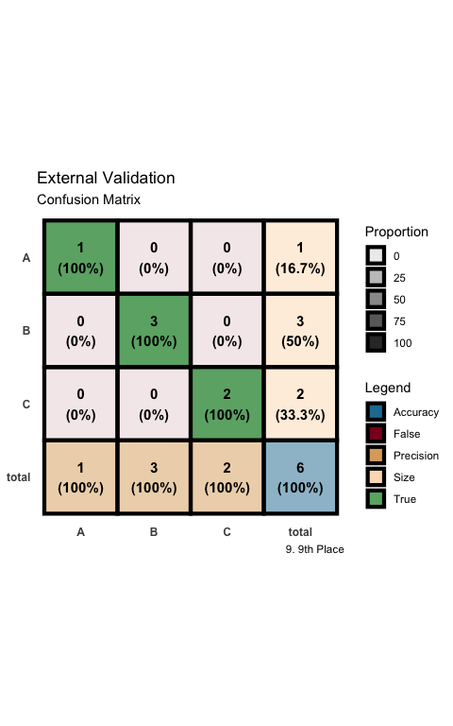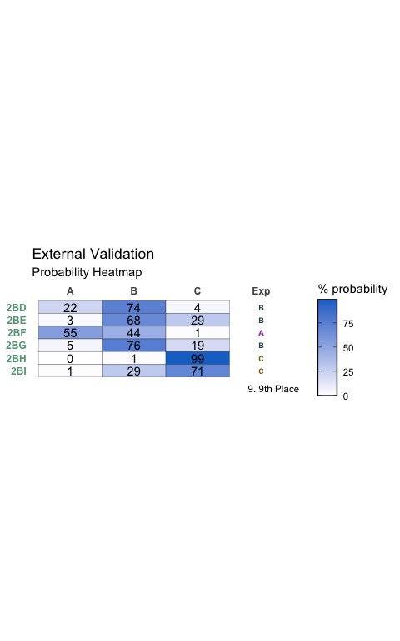

### 10th Place

Table:

Full Model Stats - Overall Accuracy and Pseudo-R2

| Accuracy | McFadden_R2 |
| --- | --- |
| 85.71% | 0.549 |

Model Coefficients

|  | x |
| --- | --- |
| -2-3- | -0.1368705 |
| Total | 0.9140378 |
| NPA_1 | 32.9947500 |
| NPA_3 | -222.4549516 |

